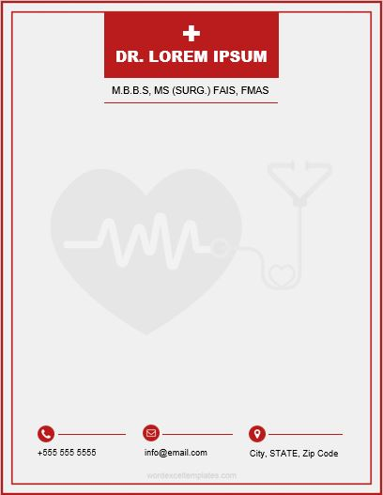­

City, STATE, Zip Code

info@email.com

+

+555 555 5555

M.B.B.S, MS (SURG.) FAIS, FMAS

DR. LOREM IPSUM