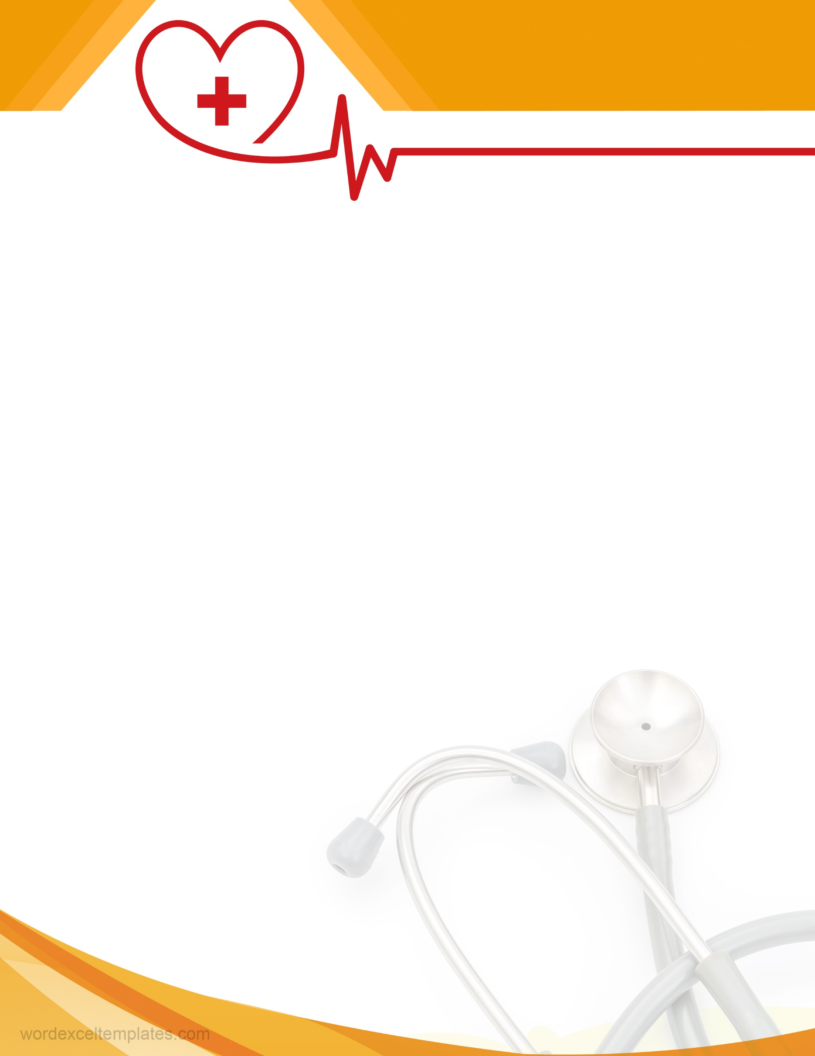­

Your address city, state, zip code  
phone: +555-456-7890  
Email: info@email.com

Lorem ipsum dolor sit met connecter

HOSPITAL NAME

Dr. Lorem ipsum

M.B.B.S, MS (SURG.) FAIS, FMAS